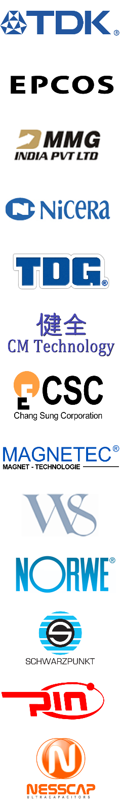 | Ferrite Cores  TDK and TDK-EPCOS the most technically advanced manufacturers in the world.  PC47/PC90/PC95(Power), N97/N92/N95(Power), HF90/T35(CMC)  MMG-India Advanced power ferrites (F48) and linear ferrite materials (P11/12) for broadband/notch filters, specializing in European style ferrite shapes  Nicera Broad temperature Power material and CMC ferrite specializing in Asian style ferrite shapes  TDG the largest manufacturer of ferrites in the world. TP4D/TP4F/TP5B(Power), TBP22/TPW33(Power)  CM Technology Amorphous Beads for high voltage surge suppression/EMI filter/noise protection.  Specialist in supplying non-standard magnetic materials, ferrite shapes and sizes. Typical Core Shapes: UU Cores(3.0 – 6.0in), EE Cores(3.0 – 8.0in), Toroids(3.0 – 6.0in), Clamp-on EMI Filters, Iron Powder  Powder Cores  Chang Sung (CSC) The world’s largest producer of powder cores. Including Sendust, MegaFlux, HighFlux and MPP.  Core Shapes: Toroids, EE/ER/EER, EQ, Block/Ellipse  Nanocrystalline/Amorphous Cores  Magnetec Premier producer of Nanocrystalline Cores in the world. Cores for Common Mode Choke, EMI Filter, Current Transformer, Motor Bearing Protection, Smart Grid Metering, Overvoltage noise protection.  Bobbins & Accessories  Win Shine, Norwe, Schwarzpunkt, and Pin Shine  Thermoplastic Bobbins from China and Germany.  Thermoset Bobbins from Germany.  Stainless Steel accessories from Asia and Germany.  Ultracapacitors  Nesscap premiere producer of Ultracapacitors and Pseudocapacitor provides 1s – 30s voltage hold-up at 2.3V and 2.7V, 3.0F – 6,000F. High voltage standard and custom modules for metering, welding, crane, forklift, fuel cell, electric vehicle, car audio, SSD and other applications |  | 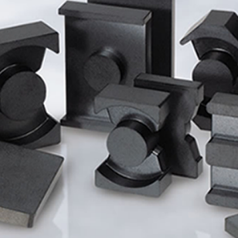  DROP SHIPPING!  MH&W can drop ship most parts direct to almost any location in the world.  - shorter delivery times  - lower cost per unit  - no ‘detour’ via the USA  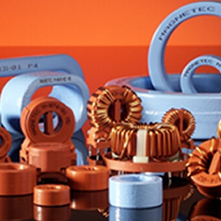  Coming soon MH&W-DIRECT!  - Ecommerce website  - Order samples and small quantities direct  - Build customized quote requests  - Browse product catalogs and documentation

